 | 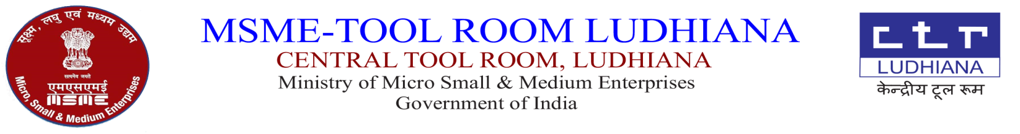  केंद्रीय टूल रूम,  सूक्ष्म,लघु एवं मध्यम उधयोग म्ंत्राल्य  भारत सरकार

CTR/LDH/1571/M.STORE/_______ DATE-15.02.2022

SUBJECT: QUOTATION FOR SCRAP ITEMS.

Dear Sir,
Sealed quotations are invited for the sale of the following scrap on the basis “As is where is basis” which should reach to this office on 24.02.2022 till 5.00 P.M.
1. Used Brass Wire 2. Turning Scrap (Steel)
3. Used M.S Wire 4. Used M.S.Pot
5. Steel Scrap 6. Copper Scrap
7. Aluminium Scrap 8. Used Grinding wheel
9. Used Carbide Inserts 10. Plastic Scrap (including damaged PVC Cistern – 41 nos.)
11. Brass Scrap ( Damaged Bib Cock 15mm -17 nos., Angle Stop/Stop Cock 15mm – 63 nos. Pillar Cock 15mm – 19nos. & Conscealed – 16 nos.)
12. Lead Scrap
13. (Used Main Switch TPN Box - 24nos. Used DP Box – 24nos. Used MCB Box – 24nos. Used Distribution Box – 24nos.Used Distribution G.I Rod – 24nos.) - 01 Set.
TERMS & CONDITIONS: -
- Your quotation should be accompanied with an earnest money of Rs: 3000/- in the shape of demand draft in favour of the Central Tool Room, Ludhiana- payable at Ludhiana or cash may be deposited on cash counter and Receipt No be mentioned in the quotation, otherwise quotation will not be considered.
- The successful party has to deposit full amount on the receipt of firm order and shall have to lift the material with in Ten days from the date of issue of aceptance letter
- PAN Number and GSTIN of the party is must for the purpose of billing & lifting the material.
- Bill from Account Deptt. is required before lifting the material.
- Taxes will be charged extra.
- Quantity & quality of material may be seen at CTR on any working day between 9.00 A.M to 4.00 P.M.
- Write on Envelop ‘’QUOTATION FOR SCRAP/USED ITEMS OF STORE’’.
- Clean the area after lifting the material. Suitable deduction will be made if not complied with.
- Item at Sr.No.1 to 12 to be sold by weight and Sr No.13 sale by lumpsum.

Yours faithfully,

(SHARNPAL SINGH) MANAGER (PROD)

A-5, Focal Point, Ludhiana - 141010

Tel: (+91)-0161- 2670059 (Ext. 237), 2670058, 2676166, 2673564

Fax: (+91)-0161-2674746.

E-mail: info@ctrludhiana.com ; purchase@ctrludhiana.com ; Visit us at : www.ctrludhiana.com

