Annexure-1
SR NO | DESCRIPTION | QTY  APPROX. | OPENING RATE  (Inc.GST)  IN RS. | EMD IN RS.
1. | Selective Laser Sintering Machine (Vanguard HiQ HS System) which includes: - Sinterstation Vanguard HS, - Monitor,-Machine CPU,--Application CPU. | 01set | 764601/-/- | 15000/-
2 | Chiller | 01no | 24000/- | 500/-
3 | Nitrogen Generator | 01no | 50000/- | 1000/-
4 | Elektra CNC wire cut EDM Model-Sprincut 734+40 ADLX+DL35 Sr.202 with Chiller & Pump unit | 01no | 175000/- | 3500/-
5 | Window AC 1.5Ton Blue Star | 01no | 4100/- | 100/-
6 | ESD Chair BSCH201 | 18Nos | 1250/-per pc | 800/-
7 | Desert cooler | 03nos | 300/-per pc | 10/-
8 | Canon Printer Inkjet G5070 | 02nos | 2836/-per pc | 100/-
9 | Canon Printer Inkjet G2000 | 01n | 250/- | 10/-
10 | Online UPS 40KVA CONSOL make with 64nos Batteries12v26Ah | 01set | 70066/- | 15000/-
11 | Used SMPS | 53nos | 40/-per pc | 200/-
12 | Used Brass Wire | 1200kg Approx. | 480/-per kg | 12000/-
13 | Turning Scrap (Steel) | 2000kg Approx. | 44.50/-per kg | 2000/-
14 | Used MS Pot | 3600kg Approx. | 45/-per kg | 4000/-
15 | Used M.S Wire | 1200kg Approx. | 41/-per kg | 2000/-
16 | Steel scrap | 1000kg Approx. | 45/- per kg | 1500/-

 | 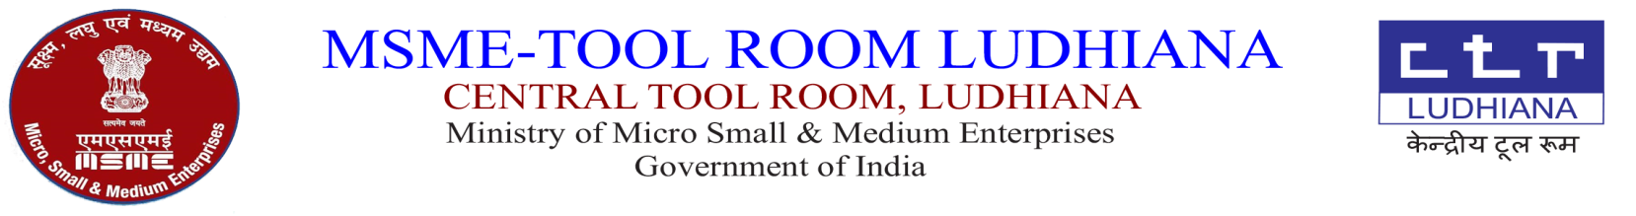  केंद्रीय टूल रूम,  सूक्ष्म,लघु एवं मध्यम उधयोग म्ंत्राल्य  भारत सरकार | 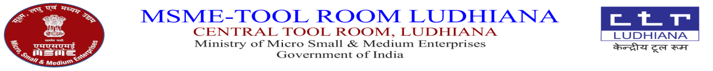
CTR/LDH/1571/M.STORE/_____ DATED:-07.06.2024

AUCTION NOTICE FOR SALE OF UNSERVICEABLE AND SCRAP ITEMS (Through GeM)

Sale of Unserviceable and Scrap items (As per Annexure-1) will be disposed off “AS IS WHERE IS BASIS”.

Terms & Conditions:

- Every bidder shall be required to deposit earnest money as per Annexure-1 either online transfer or by demand draft in favour of Central Tool Room payable at Ludhiana along with offer Account Name: Central Tool Room SBI Bank Account No.10415693035 IFSC: SBIN0002342.
- Offer should be submitted on or before 22.06.2024 by 2.00 PM.
- The Unserviceable and scrap items should be lifted within 10 days after the receipt of sale letter otherwise EMD will be forfeited.
- 100% payment has to be paid before lifting the Unserviceable and scrap items
- Bill from Accounts Deptt. is required before lifting the Unserviceable and scrap items
- The Unserviceable and scrap items may be inspected on any working day during working hours from 9.00 AM to 4.00 PM prior to bid closing.
- PAN Card Copy and GSTIN registration copy of the party is must for the purpose of billing and these are to be uploaded online.
- TCS will be charged extra.
- Material at Sr no.1 to 7 &11 will be sold by per pc.
- Materials at Sr. No.8 to 10 is to be sold to authorize E-Waste Recycler only and bidder has to submit annual return copy of last two years.
- Materials at Sr.No.12 to 16 will be sold by weight (per KG).
- For any further enquiry, kindly contact In charge Store, Tel. No. 0161-2670058,59 (Ext. No. 262,238)
- Clean the area after lifting the material. Suitable deduction will be made if not complied with.

H.O.D. (Store)

A-5, Focal Point, Ludhiana – 141010
Tel: (+91)-0161- 2670059 (Ext. 237), 2670058, 2676166, 2673564 Fax: (+91)-0161-2674746.
E-mail: info@ctrludhiana.com ; purchase@ctrludhiana.com ; Visit us at : www.ctrludhiana.com

