 | 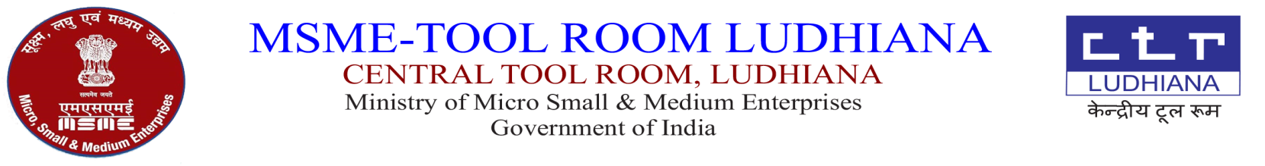  केंद्रीय टूल रूम,  सूक्ष्म,लघु एवं मध्यम उधयोग म्ंत्राल्य  भारत सरकार | 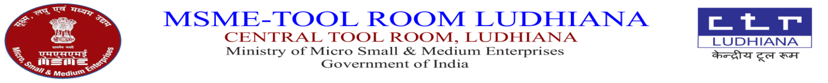
CTR/LDH/1571/M.STORE/_____ DATED:-09.10.2024

AUCTION NOTICE FOR SALE OF UNSERVICEABLE AND SCRAP ITEMS (Through GeM)

Sale of Unserviceable and Scrap items (As per Annexure-1) will be disposed off “AS IS WHERE IS BASIS”.

Terms & Conditions:

- Every bidder shall be required to deposit earnest money as per Annexure-1 either online transfer or by demand draft in favour of Central Tool Room payable at Ludhiana along with offer Account Name: Central Tool Room SBI Bank Account No.10415693035 IFSC: SBIN0002342.
- Offer should be submitted on or before 19.10.2024 by 2.00 PM.
- The Unserviceable and scrap items should be lifted within 10 days after the receipt of sale letter otherwise EMD will be forfeited.
- 100% payment has to be paid before lifting the Unserviceable and scrap items
- Bill from Accounts Deptt. is required before lifting the Unserviceable and scrap items
- The Unserviceable and scrap items may be inspected on any working day during working hours from 9.00 AM to 4.00 PM prior to bid closing.
- PAN Card Copy and GSTIN registration copy of the party is must for the purpose of billing and these are to be uploaded online.
- TCS will be charged extra.
- Material at Sr no.2, 3, 4, 7, 8 &13. will be sold by per pc.
- Materials at Sr. No.1, 5 & 6 is to be sold to authorize E-Waste Recycler only and bidder has to submit annual return copy of last two years.
- Materials at Sr.No.9 to 12 will be sold by weight (per KG).
- For any further enquiry, kindly contact In charge Store, Tel. No. 0161-2670058,59 (Ext. No. 262,238)
- Clean the area after lifting the material. Suitable deduction will be made if not complied with.

H.O.D. (Store)

A-5, Focal Point, Ludhiana – 141010
Tel: (+91)-0161- 2670059 (Ext. 237), 2670058, 2676166, 2673564 Fax: (+91)-0161-2674746.
E-mail: info@ctrludhiana.com ; purchase@ctrludhiana.com ; Visit us at : www.ctrludhiana.com
Annexure-1

SR NO | DESCRIPTION | QTY  APPROX. | OPENING RATE  (Inc.GST)  IN RS. | EMD IN RS.
01 | Online UPS 40KVA CONSOL make with 64nos battery 12v 26Ah | 01set | 70066.00 | 15000.00
02 | Selective Laser Sintering Machine(Vanguard HiQ HS System)which includes sinterstation vanguard HS, monitor machine CPU ,application CPU | 01no | 764601.00 | 15000.00
03 | Chiller | 01no | 25000.00 | 500.00
04 | Nitrogen Generator | 01no | 50000.00 | 1000.00
05 | Canon Printer Inkjet G5070 | 01no | 2809.00 | 100.00
06 | Canon Printer Inkjet G2000 | 01no | 250.00 | 10.00
07 | ESD Chair BSCH201 | 18nos | 1250/- per pc | 800.00
08 | Desert Cooler 16’’ fan | 01no | 550.00 | 50.00
09 | Used MS Wire | 1200 kg approx. | 34.20/-per kg | 2000.00
10 | Turning Scrap (Steel) | 2000kg approx. | 35.50/-per kg | 2000.00
11 | Used MS Pot | 3600kg approx. | 35.50/-per kg | 4000.00
12 | Steel Scrap | 1000kg approx. | 35.50/-per kg | 1500.00
13 | Used SMPS | 53nos | 40/-per pc | 200.00

